November 2021

v
ol.

4

What
’
s up

The newspaper of 45 Primary School in Bytom
IN THIS ISSUE - young Polish music artists manga &anime
recipe for the autumn tea travels round Europe

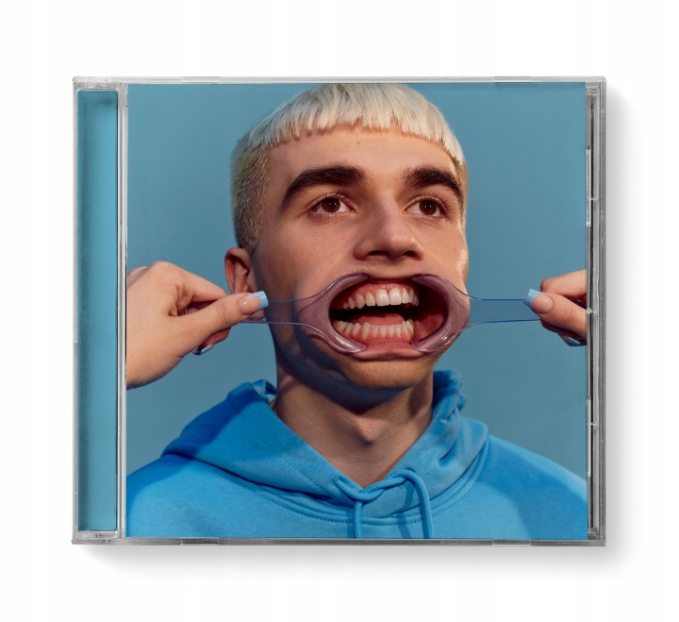

Michał ‘Mata’ Matczak is one of the most popular Polish artists of the young generation. Michał was born on 14th July 2000 in Wrocław.
Mata has released two albums, which were both awarded the 4th
platinum record and the 2nd platinum record, as well as two mini albums.
He has collaborated, among others, with such artists as Quebonafide, Taco Hemingway, Żabson and White 2115.
Mata’s achievements in the course of his 3-years-career:
- in September 2020, he received four statuettes in the hip-hop industry competition "Popkillery" (categories: the discovery of the year and the single of the year)
- on 6th September he became the first living Polish artist to break the barrier of 2 million listeners on Spotify and also as the only Polish artist on the prestigious Billboard List.
To sum up, Mata is one of the most popular music artists in Poland, who has a chance to become a world music star.
by: anonymous
Sources:wikipedia.org, facebook.com

One of the students of our school travels the world with his parents. He proves you don’t have to be a millionaire. All you need is a good organization and willingness to visit new places.

His first trip to Croatia in 2013.
Then Bulgaria in 2014, Germany – Frankfurt

Germany – Dortmund 2018, England – London 2019, Tunisia – Djerba 2019,

Italy – Milan 2019, Norway – Bergen 2019, Austria – Vienna 2020,

Cyprus – Paphos 2021, Czech Republic – Prague 2021, Italy – Milan 2021,

Hungary – Budapest 2021. He visited these countries before he was 14 years old and learned a lot thanks to it.
by: Piotr Jędrysik

-------------------------------------------------------------------------------------------

by Karolek

What is manga?
Hi, I’m Luvxmoonsx and I really like reading manga. I would like to tell you what is interesting about it.
Manga are Japanese books that are not read from left to right like normal books but from right to left. They are similar to comics, they have pictures and text. There are many genres, such as romance, horror or about ordinary teenagers with powers. Manga can be bought stationary as well as through the internet. The pages of manga are black and white. There are some films or series based on manga. They are called anime.

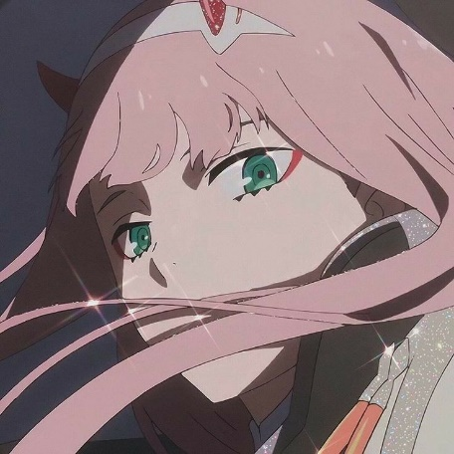

What is Anime?
Anime, better known as 'Chinese cartoons' are not actually from China. They’re from Japan! The abbreviation in Japanese is from the English word "animation" which is pronounced in Japanese animēshon. It means an animated film, but in Japan this term is used to describe all animated films and series, regardless of their country of origin. There are a few types of anime:
- bishōjo – anime in which beautiful girls play an important role,
- shōnen – anime intended for boys,
- mahō shōjo– anime about teenage heroines possessing supernatural powers
and some other like: romantic, psychological, science-fiction, school, comedy, drama, action, hero, thriller, sport, etc.
~ By: Bombiasz
sources: wikipedia.org, pinterest.com
Hip Hop
Hi, I'm Karolina and I'm going to tell you about my favourite style of dance- hip hop.
This dance isn't the easiest but I think it is worth trying. We need a lot of strength, energy and being systematic. In this dance, improvisation is very important. During the dance the strong work of legs, bent knees and a sense of beat and gesticulation are important.
It is a dynamic and energetic style. If you like to move to the rhythm of vivid music - this type of dance is for you.
by: Karolina Bęczkowska
-------------------------------------------------------------------------------------------------------------------------------
Young Leosia- Sara Leokadia Sudoł
Leosia, actually Sara Leokadia Sudoł, was born on August 13 1998 in Szczecin. She is a Polish singer, rapper, song writer, sound enginner and DJ. Young Leosia is a young, talented and ambitious artist who become famous in May after publication of her 16hotchallange2. It’s popularity increased after the release of the single ,,wispy”, produced by Borucci, the producer of Taco Hemingway’s hits. Young Leosia is also a DJ by profession. Leosia has been learning music since she was 12 years old. During this time she graduated from the first degree music school. She also attended music school in Wrocław but she didn’t complete it. Leosia in now currently 23 years old and her most popular song is ,,Baila Ella”. by Nadia sources: sources: facebook.com, wikipedia.org
Robert Lewandowski
My favourite sport is football. It is the most famous sport discipline in the world. Four billion people watch it all over the world every year. There are many great football players, for example Cristiano Ronaldo, Leo Messi but I think Robert Lewandowski is the best one. He plays in our national team and he is also a player of Bayern Munchen club in Germany. I love his game style and his dribble he plays as a striker. He broke many of the world records of goals, for example in 2019 he set a new record for fastest time to score four goals in a Champions League match.
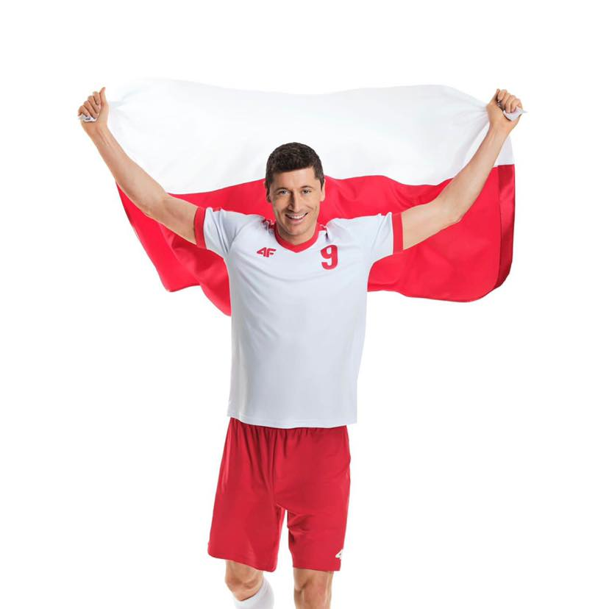
by: megapenetrator69
sources: wikipedia.com, facebook.com
------------------------------------------------------------------------------------------------------------------------------------------
Editor of vol.4: Amelia Babiuk Caregiver: Aleksandra Ciechowska

